RÖHM Reduces Unnecessary Parts to Increase Revenue and Productivity
RÖHM uses the Parts Management System PARTsolutions to streamline design and interoperability among their 60 facilities
AUGSBURG, Germany, October 2nd 2014 – RÖHM is known as a worldwide leader in clamping and chucking tool technology. To create their products they use more than 12,000 standard and supplier products, in addition to their own internally designed parts. With so many parts, streamlining product search and selection was critical to meet the needs of RÖHM’s 1500 employees at 60 facilities worldwide.

RÖHM has worked closely with CADENAS, utilizing their Parts Management System PARTsolutions to reduce duplicate parts, aide part search and reduce design time.

Before PARTsolutions was implemented at RÖHM, CAD parts were manually filed in SAP, requiring a lot of effort with every new part. Depending on the type, each newly created part would cost the company at least 200 Euros ($270).

RÖHM counts on reliable solutions

This is why RÖHM needed a Parts Management System that could reliably and accurately manage all components with relatively little effort. The goal was to simultaneously reduce the parts diversity while reducing costs.

By standardizing design and implementing an easy method of supporting the parts catalog, the design processes is streamlined, saving time and finances for the company. Using parts over and over, instead of re-creating them, reduces the burdon for departments like procurement and logistics.

RÖHM has always relied on robust software solutions, finding a new Parts Management System meant it would have to be equally as reliable. RÖHM has already had very good experiences with solutions by CADENAS in use at the company; therefore the Strategic Parts Management PARTsolutions immediately became the focus of attention.

Increase in efficiency results in cost savings

“In the eight years we have been using the Parts Management System, our product range has considerably increased. Needless to say this resulted in an increase of required parts as well. However, we have seen that the new creation of parts increased only slightly compared to the diversity of parts used for our new developments. By using PARTsolutions unnecessary parts growth is avoided,” said Heinrich Müller – CAD Administrator at RÖHM GmbH.

You can find all information about the RÖHM Parts Management System in the case study at: www.cadenas.de/partsolutions/customers/success-stories

Press Image:

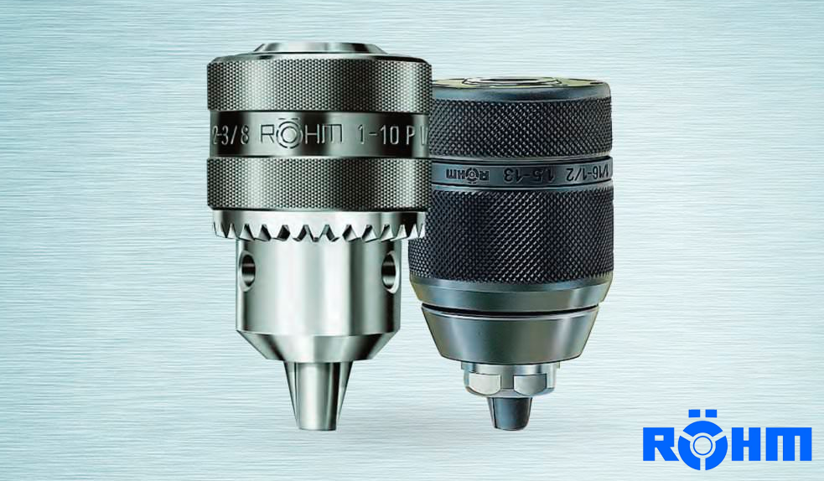
Caption: The Strategic Parts Management PARTsolutions by CADENAS reduces at RÖHM unnecessary parts and increases revenue and productivity.
About CADENAS

CADENAS is a leading software developer in the areas of Strategic Parts Management and parts reduction (PARTsolutions), as well as Electronic Product Catalogs (eCATALOGsolutions). With its customized software solutions, the company acts as a link between the component manufacturers with their products and the purchasers.

With its 300 employees at 14 international subsidiaries, the name CADENAS (Hispanic: process chains) has been standing for success, creativity, support and process optimization since 1992.

For further information, please visit: www.cadenas.de/en

