# CADENAS established a new branch office in Turkey German software manufacturer strengthens its international focus

**Augsburg, Germany, 5th May 2015.** The CADENAS AG established a new branch office on the Bosporus on 1 April 2015. With its office in Istanbul, CADENAS Software Solutions Turkey will continue to promote Strategic Parts Management and Electronic CAD Product Catalogs on the Turkish market.

Akin Terzi advises and supports existing and prospective customers in Turkey locally and in their language. His target is to make CADENAS software solutions popular in the region and establish the company as an important partner on the market. “In the long term it is my goal to build a strong and successful bridge between engineers and manufacturers“, says Akin Terzi.

Establishing a branch office in Turkey is the consequent pursuit of CADENAS’ previous expansion course. In January 2015, a CADENAS new branch office in Bristol, Great Britain, was opened.

In total, the software manufacturer CADENAS, with its head office in Augsburg, Germany, has about 300 employees at 17 worldwide establishments, e.g. USA, Great Britain, France, Italy, China, South Korea, Brazil and Japan.

**Contact**

CADENAS YAZILIM HIZMETLERI  
İcadiye Mh.  
Muhtar Mehmet Özen Sk No:7  
34674 Üsküdar/İstanbul  
Turkey

Phone: +90 (0)216 695 24 01   
e-mail: [A.Terzi@cadenas.de](mailto:%20A.Terzi@cadenas.de)

**Press Images:**

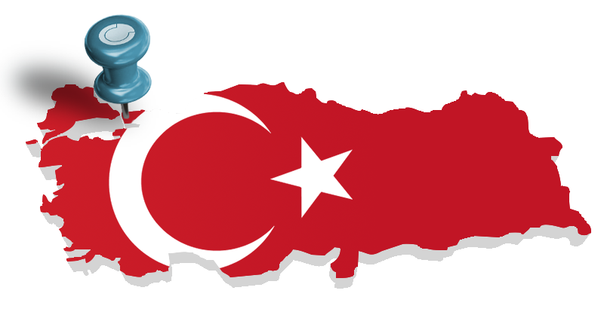

**Caption:** The CADENAS AG established a new branch office in Turkey.



**Caption:** Akin Terzi advises and supports existing and prospective customers in Turkey locally and in their language.

The press release and the images are available for download on our website: www.cadenas.de/press/press-releases

**About CADENAS**

CADENAS is a leading software developer in the areas of Strategic Parts Management and parts reduction (PARTsolutions), as well as Electronic Product Catalogs (eCATALOGsolutions). With its customized software solutions, the company acts as a link between the component manufacturers with their products and the purchasers.

With its 300 employees at 17 international subsidiaries, the name CADENAS (Hispanic: process chains) has been standing for success, creativity, support and process optimization since 1992.

For further information, please visit: www.cadenas.de/en