ATEK offers new CAD product catalogue for gearbox configuration

Augsburg, Prisdorf, March 7th 2012. As one of the leading manufacturers of angular gears, ATEK Antriebstechnik Willi Glapiak GmbH, based in Prisdorf, presents its new CAD catalogue with the option of configurating gearboxes. At http://atek.partcommunity.com, CAD models for numerous ATEK products are now available immediately for downloading free of charge. The new 3D CAD ATEK download portal is based on the PARTcommunity technology from the Augsburg-based software manufacturer CADENAS GmbH.
3D CAD models in all the current CAD formats
In the new ATEK CAD product catalogue, the 3D CAD models contain all the vital information such as dimensions, performance, torques, radial forces, mass moments of inertia and other gearbox properties.

Customers of ATEK Antriebstechnik Willi Glapiak GmbH and interested parties can now download the CAD models from the ATEK online product catalogue into their CAD system in all the current CAD formats directly and conveniently, without the need for buffering, and then integrate them into their design.

The ATEK 3D CAD download portal also offers new kinds of selection options for users to find the desired CAD model of a gearbox simply and quickly.
Effective optimisation of the entire process chain
„Our new Electronic CAD Product Catalogue offers high flexibility to respond to specific customer demands and optimize our internal processes”, says Uwe Brandt, design and development manager at ATEK Antriebstechnik Willi Glapiak GmbH.

ATEK supports its customers as early as the planning and design stages with CAD data and the easy to use gearbox configurations. These all reduce processing times, minimise errors and thereby contribute to cost savings. Whether in planning, design, production or purchasing, customers can use the ATEK gearbox data to optimise their entire process chain – and all it takes is a few mouse clicks.

You can reach the new ATEK 3D CAD download portal at www.atek.de or at http://atek.partcommunity.com.

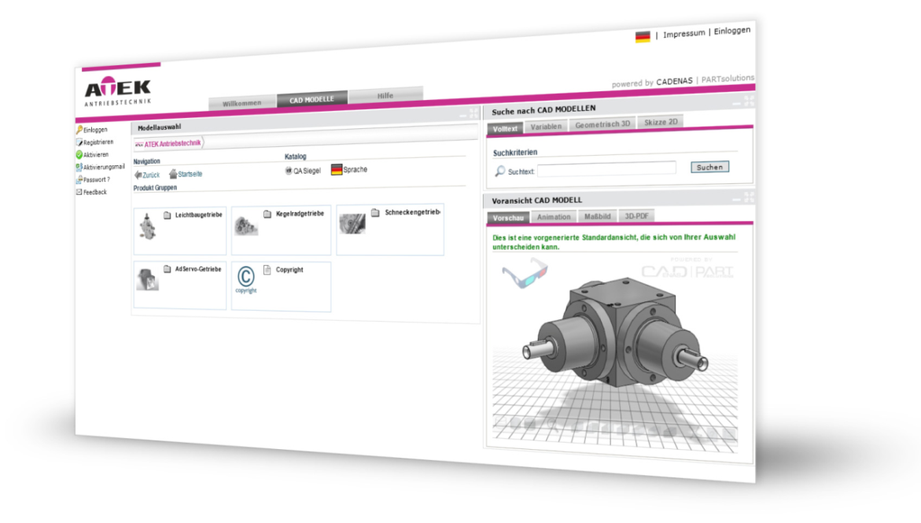
Press Photo

Caption: The new ATEK Antriebstechnik Willi Glapiak GmbH 3D CAD download portal makes CAD models of gearboxes available for customers and interested parties to download.

You can download photos and text on: www.cadenas.co.uk/press/press-releases

About CADENAS GmbH

CADENAS is a leading software manufacturer in the areas strategic parts management and parts reduction (PARTsolutions) as well as electronic product catalogs (eCATALOGsolutions). With its customized software solutions, the company acts as a link between the component manufacturers and their products and the purchasers.

With its 300 employees in 14 locations worldwide, the name CADENAS (Spanish for “process chains”) has stood for success, creativity, support, and process optimization for 20 years.

In the role of initiator and mastermind, CADENAS has already established many innovations and trends.

eCATALOGsolutions Innovations:

- Search of 3D CAD parts on Smartphones
- Use of 3D glasses to present CAD models
- Control of 3D CAD parts with the help of Wii remote control
- Support of Augmented Reality Technology
- ePRODUCTplacement – make the right part available to the right person at the right time

More information about the newest innovations as well as the company in general can be found on our homepage under: www.cadenas.de/en.

About ATEK Antriebstechnik Willi Glapiak GmbH

ATEK is one of the leading suppliers in the field of right-angle power transmission.

Wherever torques are transmitted at right angles and branch, and at the same time the highest demands are made with reference to low backlash, ATEK is your ideal partner. The angular gearboxes are distinguished by a compact structure, a wide performance range and a great number of transmission ratios and gear reductions.

Whether you’re looking for a powered drive in a conveyor system or a control drive in highly dynamic machine tools – ATEK has the customised solution for almost every application.

