PARTsolutions Becomes Sole Thinking Parts Management System with New Feature
Find CAD parts automatically with the new background search by CADENAS

Augsburg, August 5th 2010. With the upcoming version of PARTsolutions, finding similar parts has been greatly simplified, reducing costs more efficiently and lastingly. With its new automatic background search, CADENAS GmbH introduces a new function of the next version 9.02 of the strategic parts management system PARTsolutions. In the future, while users work on their constructions within the software solution PARTsolutions, the geometric similarity search will automatically be started in the background. For the currently opened CAD part, geometrically similar CAD models will be found and listed below the 3D preview for the user. The search is conducted automatically in the background while the user continues to work as usual.

The new function of the automatic background search simplifies the construction process of engineers, since alternative CAD supplier or own parts are automatically displayed. Thus duplicates are avoided in the company and costs saved.

Finding, reducing and managing components and standard parts has now been further simplified by CADENAS’ strategic parts management system. Since about 70% of manipulable overall product costs can be traced back to the planning in the development phase, CADENAS’ software solution already begins assisting at the engineering level. PARTsolutions seamlessly integrates itself into the process chain and covers the entire product cycle.

Press Photo

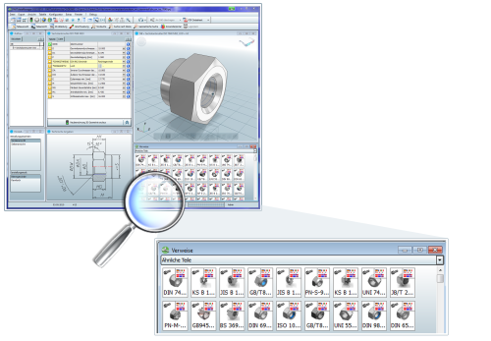

Caption: The geometric similarity search will automatically be started in the background of PARTsolutions Version 9.02.

The press release, photos, as well as a video, are available for download under: www.cadenas.co.uk
News & Events / Press Release

About CADENAS GmbH

CADENAS is a leading software manufacturer in the areas strategic parts management and parts reduction (PARTsolutions) as well as electronic product catalogs (eCATALOGsolutions). With its customized software solutions, the company acts as a link between the component manufacturers and their products and the purchasers.

With its 300 employees in 12 locations worldwide, the name CADENAS (Spanish for “process chains”) has stood for success, creativity, support, and process optimization for over 18 years.

In the role of initiator and mastermind, CADENAS has already established many innovations and trends. These include:

- Part selection through sketching
- The 3-D similarity search
- The mobile search
- Use of the Quick Response Codes
- Use of 3-D glasses
- Controlling 3-D parts with the help of Wii remote control
- Support of the Augmented Reality Technology

More information about the newest innovations as well as the company in general can be found on our homepage under: www.cadenas.co.uk.

