MAN Truck & Bus counts on CADENAS PARTsolutions
Reduce part multiplicity? Yes MAN can!

Augsburg, January 17th 2011. MAN Truck & Bus AG successfully implemented CADENAS’ strategic parts management PARTsolutions in order to be able to manage and reduce parts worldwide, thus increasing the reuse of existing parts. Now MAN Truck & Bus AG and CADENAS GmbH are publishing a brochure highlighting the joint success story about the use of PARTsolutions at the commercial vehicle manufacturer of buses and trucks.

Since the beginning of the year 2009, the MAN Truck & Bus Group has been using CADENAS’ strategic parts management system PARTsolutions at its worldwide locations. It is the goal of PARTsolutions, to simplify the process of finding, reducing and managing CAD parts in companies, and thereby reducing costs in the long run.

MAN Truck & Bus AG is the largest company in the MAN corporate group and one of the leading international commercial vehicle manufacturers for buses and trucks.

“Already reducing the part assortment in the development phase”
Studies confirm that about 70% of manipulable total product costs lead back to planning in the development phase. CADENAS’ strategic parts management with the geometric similarity search therefore already begins in the construction phase. PARTsolutions especially targets the engineering department and is being used at about 1,300 workstations worldwide. “The consequent use of the parts management system PARTsolutions already enforces the reduction of part selection in the early stage of development,” says Frank Jürgens, Manager Standardization Department ESS at MAN Truck & Bus AG.
Improvements at MAN Truck & Bus due to PARTsolutions
- The strategic parts management system integrates all MAN parts inventories from other information sources and supports all current CAD systems.
- Accessing part information from all worldwide MAN locations is possible.
- Research and search options for existing parts were visibly improved and simplified due to the geometric similarity search.
- The MAN internal processes were optimized across all departments.
“We see the project that implemented PARTsolutions as a great success. We gained many new functionalities that have fundamentally simplified and improved a number of processes at MAN Truck & Bus,” notes Stefan Bernhardt, Chief Department Manager IT Engineering at MAN Truck & Bus AG.

„MAN Truck & Bus has offered us some good ideas for improvement concerning detail for coming versions. As a very customer-oriented company, we appreciate all suggestions and are looking forward to a long and positive partnership,” declares Jürgen Heimbach, CEO, CADENAS GmbH.

The complete brochure can be downloaded on www.cadenas.co.uk under the category: News & Events / Press Release.
Press Picture

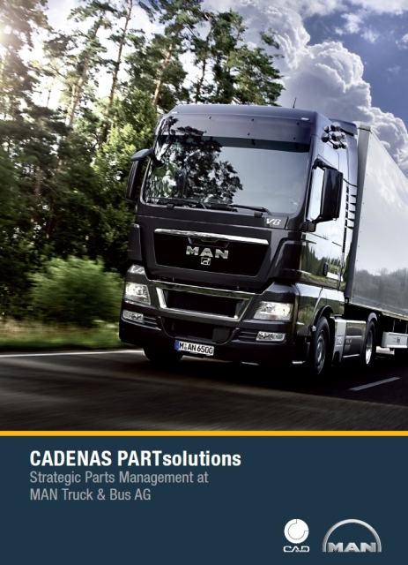
Caption: Implementation of Strategic Parts Management at MAN Truck & Bus AG.

2,825 characters

Images and text, as well as the complete brochure, can be downloaded on our website: www.cadenas.co.uk
News & Events / Press Release

About CADENAS GmbH

CADENAS is a leading software manufacturer in the areas strategic parts management and parts reduction (PARTsolutions) as well as electronic product catalogs (eCATALOGsolutions). With its customized software solutions, the company acts as a link between the component manufacturers and their products and the purchasers.

With its 300 employees in 12 locations worldwide, the name CADENAS (Spanish for “process chains”) has stood for success, creativity, support, and process optimization for over 18 years.

In the role of initiator and mastermind, CADENAS has already established many innovations and trends in its two business areas:

PARTsolutions Innovations:
- Search of CAD parts using topologies
- CAD parts similarity search runs automatically in the background
- CAD parts search through sketching

eCATALOGsolutions Innovations:
- Search of 3D CAD parts on Smartphones
- Use of the Quick Response Codes
- Use of 3D glasses to present CAD models
- Control of 3D CAD parts with the help of Wii remote control
- Support of Augmented Reality Technology

More information about the newest innovations as well as the company in general can be found on our homepage under: www.cadenas.co.uk.

