SMS group avoids duplicates and offers the best possible data quality through PARTsolutions
PARTsolutions from CADENAS allows for all SMS group locations to have central access to the same pieces of information

Germany, Augsburg, 15th February 2017. The SMS group has been using the Strategic Parts Management PARTsolutions from the German software manufacturer CADENAS since 2006. As a globally operating company, SMS has the target to orient its parts management more internationally and to integrate all SMS companies worldwide with its catalog parts, manufacturers and standards into SAP by 2020.

The SMS group, under the roof of SMS Holding GmbH, is a group of global players in machinery and plant construction for the steel and nonferrous metals industry. More than 14,000 employees generate global sales of some EUR 3.4 billion.

Parts management department provides high quality data

There is a central department at the SMS group responsible for all tasks around the topic of „parts management“. With the help of PARTsolutions the company’s design engineers are provided with, amongst other things, currently updated manufacturer catalogs and capable catalog parts with multi CAD. These are provided in many CAD formats including: Creo Parametric, Autodesk Inventor and Auto CAD. Moreover, SMS internal catalog and standard parts are created with their specific requirement as 3D CAD geometries and made available in the Parts Management System from CADENAS.

Central access to all locations for identical parts information

Numerous locations of the SMS group worldwide already access the Strategic Parts Management PARTsolutions. Parts information used to be stored at individual locations and were updated and made available only after hours on end. Parts data of the SMS group have been centrally stored on one server, the PARTapplication, since March 2015. Thus, all locations now have access to the same parts data, which are made available to design engineers much faster. „We are one of the first customers to use the CADENAS web service for the quick distribution of data to distant company locations. We are excited how well everything works,“ says Bernd Postaremczak, Head of Parts Management SMS group GmbH.

Challenges for parts management in a globally operating company

Especially with the international orientation of parts management, the SMS group currently faces a number of challenges. A parts management department is being established in India at this time. This means that, above all, the language barrier must be overcome. Previously most of the regulations for parts management have been in German, but now English is required. The same applies to the standards and data sheets as well as to the folder names, which must also be made available in English. In addition, international standards must be updated and, for example, sizes and dimensions given in international measuring units.

„Foreign sites are not to merely be extended workbenches in the future, thus our company has the target of integrating all SMS group companies in SAP by the year 2020. This means a change to the ERP system for all newly integrated locations, which will involve a number of challenges. For each conversion, all standard and purchase parts must be matched. Moreover, numerous new standards and new manufacturers at every location must be set up in SAP,” says Bernd Postaremczak, SMS group GmbH. „An effective parts management means constant data maintenance and PARTsolutions from CADENAS supports us optimally."

More information can be found in the case study of the SMS group and CADENAS at: https://www.cadenas.de/files/cadenas/Downloads/PDF/Referenzen/EN/PARTsolutions_SMS-group_case_study_EN.pdf
Press Images:

Caption 1: The SMS group, under the roof of SMS Holding GmbH, is a group of global players in machinery and plant construction for the steel and nonferrous metals industry.

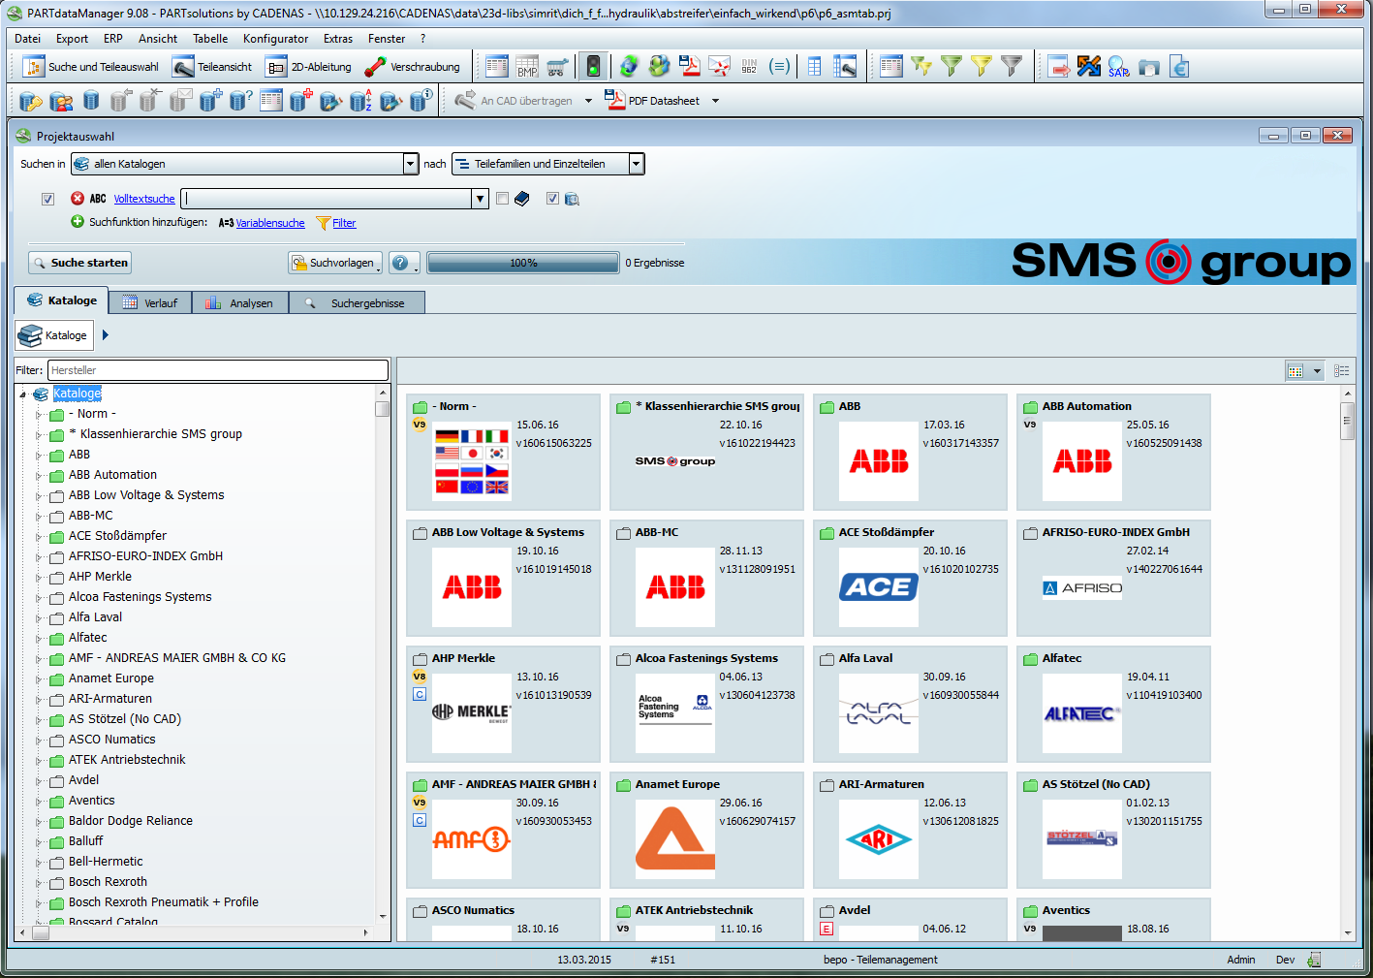
Caption 2: Overview of the catalogs in PARTsolutions by the SMS group.

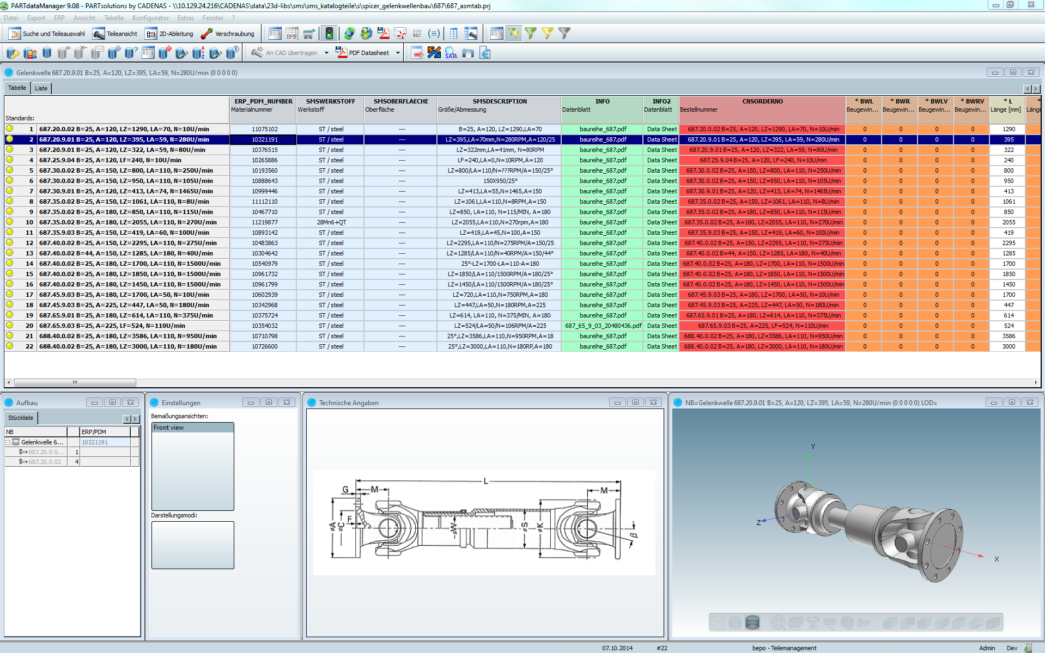
Caption 3: All important component information at a glance with PARTsolutions.

This press release and accompanying images are available for download from our website: www.cadenas.de/press/press-releases

About CADENAS

CADENAS is a leading software developer in the areas of Strategic Parts Management and parts reduction (PARTsolutions), as well as Electronic Product Catalogs (eCATALOGsolutions). With its customized software solutions, the company acts as a link between the component manufacturers with their products and the purchasers.

With its 300 employees at 17 international subsidiaries, the name CADENAS (Hispanic: process chains) has been standing for success, creativity, support and process optimization since 1992.

For further information, please visit: www.cadenas.de/en

