Samtec Reduces Download Times from 24 Hours to 24 Seconds

Connector manufacturer uses innovative online configurator to boost electrical component business

Germany, Augsburg, 6th April 2017. The engineer’s design process has become more complex as we have entered the digital realm. Digital product samples have become just as important as physical product samples. Samtec began a digital transformation more than 15 years ago by creating a unique library of 3D CAD models in-house. The models were built per customer request and posted online for downloading.

“Over time that approach proved limited,” says Daniel Williams, Business Analyst at Samtec, Inc. “The models were static and instantly outdated. We could only support a few standard formats. Additionally, our storage costs were rising and our response times slowed as the number of models requests increased. We needed a different solution.”

Digital performance proves an air-tight ROI
Samtec’s interactive catalog of 3D CAD models is built upon CADENAS eCATALOGsolutions platform, which leads the industry with more than 700 active clients. “Every minute an engineer downloads a Samtec product model into one of their designs, around 26,000 downloads per month. That's a marketing tool that performs,” says Jay Hopper, VP, Marketing & Business Development, CADENAS PARTsolutions LLC, the US subsidiary company of CADENAS Technologies AG.

Reducing Sample Times from 24 Hours to 24 Seconds
“CADENAS PARTsolutions LLC replaced our entire 3D CAD model catalog in 9 months, and now the CAD models are dynamically generated in real-time on their servers and instantly available in 150 current formats,” says Daniel Williams, Business Analyst at Samtec Inc. “We are known for our 24 hour sample model, but we are now accelerating that by providing digital samples within 24 seconds.”

Using a world-class platform to meet exacting requirements
“For Samtec, 3D model accuracy and reduced download times were essential. CADENAS PARTsolutions LLC brought those capabilities to the table,” adds Williams. “The opportunity to integrate with a world class platform and collaborate with their technical support team proved indispensable. They exceeded our expectations to create the exact solution we needed. Their implementation team responded quickly and professionally as the project progressed.”

The complete case study can be downloaded here:
www.cadenas.de/ecatalogsolutions/customers/success-stories

Press Images

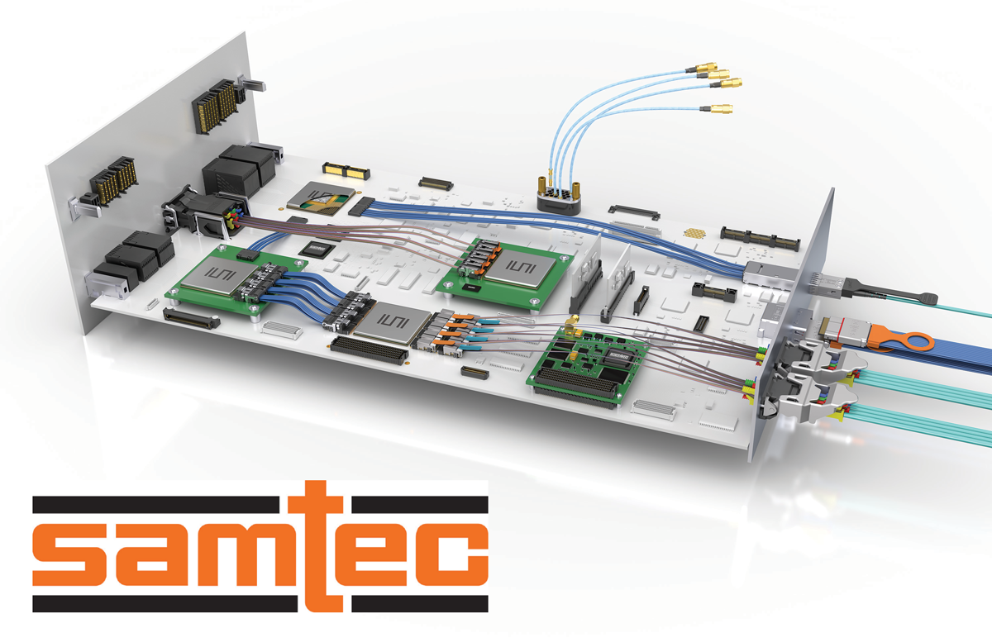
Caption 1: Samtec, Inc. is a global manufacturer of a broad range of electronic interconnect solutions.

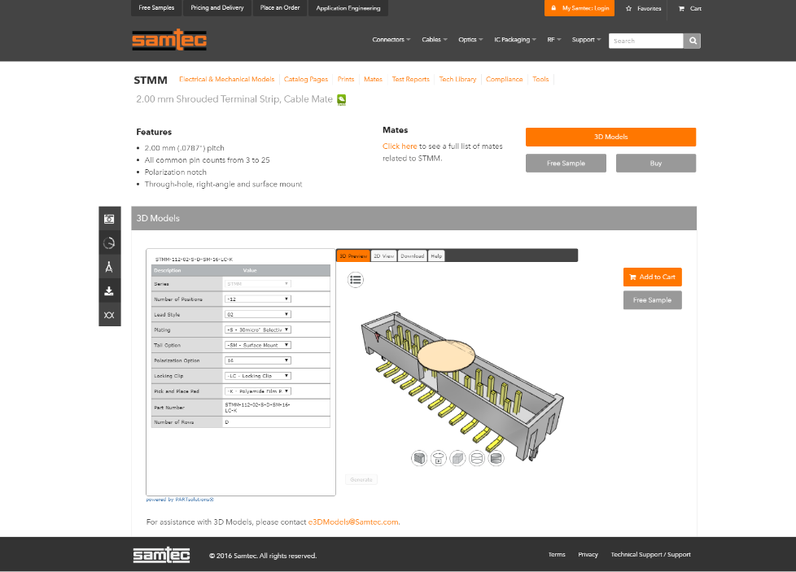
Caption 2: Samtec's new Interactive Product Configurator and Electronic Product Catalog based on eCATALOGsolutions technology by CADENAS.

This press release and accompanying images are available for download from our website: www.cadenas.de/press/press-releases

About CADENAS

CADENAS is a leading software developer in the areas of Strategic Parts Management and parts reduction (PARTsolutions), as well as Electronic Product Catalogs (eCATALOGsolutions). With its customized software solutions, the company acts as a link between the component manufacturers with their products and the purchasers.

With its 300 employees at 17 international subsidiaries, the name CADENAS (Hispanic: process chains) has been standing for success, creativity, support and process optimization since 1992.

For further information, please visit: www.cadenas.de/en

